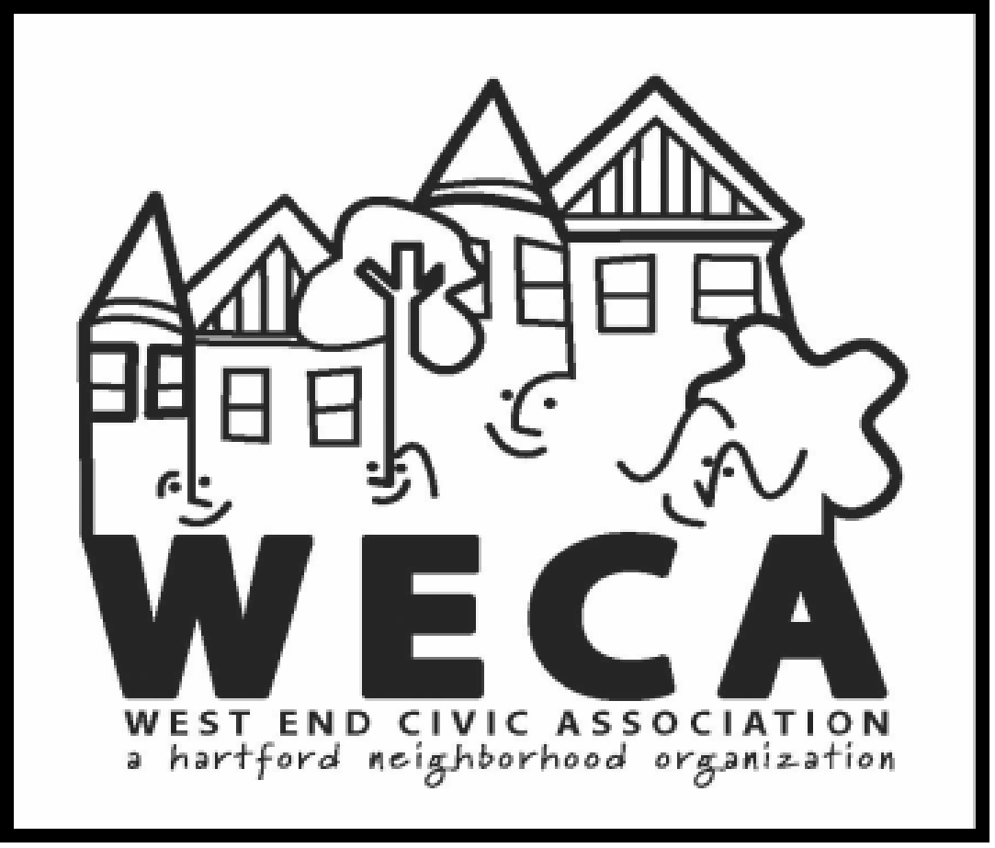

**West End Civic Association & NRZ**

**8:00p WECA Board Meeting**

**JULY 15, 2020**

**8:00 WECA Board Meeting**

Attendees: NN, MM, LE, SB, DK, ME, SM, LH, RT, KB

**OLD**

**Nealie – Summarize Minutes from June, 2020**

**Motion / Vote to Approve**

Voted to approve.

**NEW Issues of Discussion:**

**Financial Report – David**

Sent spreadsheets; Very excited about the extra $1K; Membership brought in 600-700$ net($1500 in contributions by the QR code or using paypal mostly). ME – Has been getting forms but it doesn’t indicate if they’ve paid. DK will get list of checks to ME.

**Discussion / Recommendation on PorchFest to Porchfest Committee**

**Motion / Vote re Recommendation**

DE: We have $1500 in the budget to support but we only end up spending about $800. DK: Willing to support but inclination is to say postpone. LE: Willing to postpone. SM: we raised $3100 but we spent $3900 – balance covered by WECA was $800 – so the cost this year would be significantly less.

Tabled till after the committee meets.

**Discussion / Recommendation on Sept Fri G-Rated Nite Movie to Movie Committee (Ken)**

**Motion / Vote re Recommendation**

SB: People reached out because its late and for adults; can we add another night and bring a G rated movie?

DK there is a license fee for the movie and the projectionist ~$700 per movie so he is in favor of supporting Ken to do another movie to meet those requests.

KB: can we check the time of the movie start – maybe a 7pm start time? In favor in general.

DK: Sundown is at 7pm so we could ask for earlier. SB: Let’s try it.

Board: In favor.

**Discussion / Vote on Childrens’ Museum Move & Beckett / Berquist participation**

**Motion / Vote to Approve**

SB: In the next stage, fundraising has been successful. SB and KB have been asked to be part of stakeholder group. KB: No conflict, invitation for someone in the neighborhood to be a representative of the neighborhood. Both she and he will participate.

**Membership Report – Michelle**

We have some unaddressed post cards we can drop at businesses if we have places to drop. Tangiers and Expressos, Monte Alban, South Whitney, Tisanes, any other businesses.

**Summer Music Report - Kyle**

Mood changed a little bit so the music has fizzled a bit. He does have a contact he can reach back out to in the near future. Let’s let it go now and pursue later. He did get one email from a neighbor complaining about the noise and he responded.

**Clean up Report / Update – Guy**

Tabled.

**Online Arts / Music Lessons / Local Artists / Joey Marsocci Update - Lindsay**

LE: there wasn’t a lot of interest; RT: perhaps we can table some of these for the next time we are stuck inside.

**Public Safety Report – Matt / Discussion re Proposed Letter (attached)**

**Motion / Vote to Approve**

MM: More work to be done still - will change his letter to be addressed to Bronin and nest our letter with Asylum Hill and send a new draft based on the issues going on with the issues with the police chief at the moment. With that in mind, suggesting looking at our goals as an organization but now is a good time to look at HTFD next is doing and nest ours with theirs to have partnership between the NRZs to meld on some of the other issues to include the police, education, etc.

LE: HTFD Next – working on the website and to make all of their documents available online so each NRX has their own mini platform; to share resources and ideas to share knowledge; there has been good participation.

MM: Meeting tomorrow, vote on acceptance of the new members; June was the slide we put together. The HTFD Fund for giving – they are soliciting for members for the committee to sit on to distribute the 100K$.

SB: What is our position on the police review view; MM: I think they should be using it. Also – switching over to the scholarship – the app package is mostly together and he will have that for Aug 1 to accept submission, to review and approve for early Sept. For people doing higher education and/or vocational schools.

LE: We need a committee to review the application.

SM: The letter should be published in the newsletter and a link to the website.

**Update on the Pantries – Nealie / Discussion re Add’l Funding**

**Motion / Vote to Approve**

NN: Pantries are working well – would like to get another $500 for restocking.

DK: Is WECA supporting the WEST BLVD pantry? NN: No WECA is only supporting evergreen and N Beacon at the moment; SB: Can we recognize the bike messenger (Joseph Matthew) in the newsletter? LH will add Joseph Mathews to the newsletter as a thank you.

Voted: Yes.

**Chess Table/ Tables in Elizabeth Park Update – Nealie**

We need to wait no definitive date yet.

**Beautification Update – Mike?**

Absent - Tabled.

**WEFM Update – WEFM Manager?**

RT: it is going well, long lines, lots of produce; People are respecting SD and wearing masks.

**Education Update – Erin?**

Absent - Tabled.

**Racism Workshop Update – Max?**

MC: People have responded. Question – do we want the people that facilitate these to be WEND residents only?

LE and MM: Go for quality – no need to limit option to the WEND.

**Survey Responses –Racism Workshop / Braza – SLB**

SB: There is interest based on responses from the newsletter; LE: Can reach out to Max.

RT: My contact can do a history of racism

SB: There is interest we could record on a meeting night, he seems really interesting.

DK: election is in Oct, and the meeting is the 4th Tuesday in Sept. the 22nd can we do then?

SB: cannot comment on survey response tonight.

**Strategic Goals for 2020 - 2021**

LE: We should have a meeting specific to this and have items to review in advance.

SB: Our existing strategic plan is very ambitious, we should pick some items from it to focus on.

SM: Whoever is replacing SB should participate in that process.

Summary of the Search Committee for the election: SM:The committee has done some work and has a beginning list of people to pursue. So far feedback is - People would like to have more social events. We can add a solicitation to the newsletter but SM believes no one will respond to cold calls. We need to ask specifically. RT: We also head that small issues often become the focus of meeting rather than the bigger issues that impact more people.

**Meeting Closed at 9:05**

**Email from Children’s Museum to WECA:**

*I know it’s been awhile since we last communicated but I wanted to let you know we are now starting the design phase for our new Hartford facility and are planning some stakeholder meetings with a Net Zero Energy consultant, Eversource and others. I am reaching out to request that you please give consideration to joining this stakeholder group overseeing the design task for our new West End Net-Zero Energy facilities.*

*This will likely involve several virtual sessions over the next two to three months and will provide you an opportunity to provide guidance on this critical aspect of our future Hartford home.*

*Please let me know your thoughts on this at your earliest convenience.*

**ADDENDUM**

**WECA Seeks Proposals For Supporting our community during the Covid-19 Epidemic**

In place of the grant program of past years, the West End Civic Association is requesting grant proposals to support our mission to foster community engagement and enhance quality of life for West Enders during these very difficult times. WECA board is able to provide financial support for activities that are important to our neighbors.

**Applications may be made for the following purposes:**

* Food insecurity issues
* Mental health support activities
* Other Civic, Cultural or Social Service programs that will benefit our community

**All applications for funding must be for events and/or programs that are:**

* Free and open to the public
* Held within the City of Hartford
* Free of any personal or financial interest

**Timing of the WECA grants program:**

The program has no specific timeframe, but grant requests will be evaluated as they are received and funds allocated ASAP

**Guidelines for proposal submissions:**

* Description of the program/event
* How will it be organized? Who will manage it?
* Who will be served? How will you outreach to participants? How many will be served?
* Why is the program needed? - be specific in demonstrating the need
* How will the program benefit the West End?
* Contact person for follow-up questions including email and phone number.
* Include a line-item income and expense budget.
* List other income sources, if any.

We encourage you to include letters of reference. We do not have a cap on the size of a grant request other than the amount available for distribution.

**Grant recipients will be asked to submit a final report on the results of the program/event funded along with pictures/videos and any community engagement results achieved.**

**Grants should be submitted to**[**WECAgrants@gmail.com**](mailto:WECAgrants@gmail.com)**.**

**Question:  Contact David Klein, WECA Treasurer at**[**dmk3975@gmail.com**](mailto:dmk3975@gmail.com)**or 860-232-2050**